Getting Ready for Secondary School

It isn’t long now before you will be visiting your new school as one of its pupils for the first time. On that day you will meet your new teachers, find out who your tutor is and start to learn about the school and what you can expect to do there and what they expect of you.

At first you might find it difficult to find your way around the school. Even the journey to school might be more complicated than you are used to. The purpose of this booklet is to help you get used to the idea of secondary school and to look at some things that may be worrying you, or that you haven’t even thought about. If you have any other questions or worries just talk to your teacher or your parents. We all want you to enjoy your new secondary school and do well in the future, and one way we can help is to make sure that you have a good transition.



Now let’s start with you trying to navigate your way through the maze below to help Adam Ant get to his classroom on time, before we complete the questionnaire and the word search!

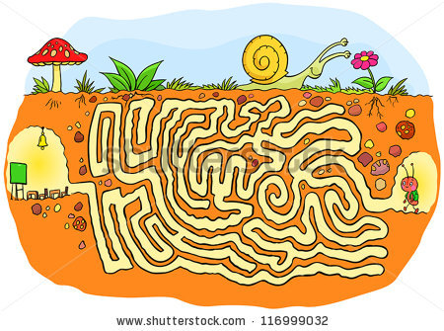

Getting Ready for Secondary School

In year 7 I am looking forward to . . .

In year 7 I am a bit concerned about . . .

I think it would help my move to Secondary School if . . .

WORD SEARCH
Find the following words (all about secondary school) hidden in the word search below:
primary, secondary, history, geography, maths, english, science, tutor, headteacher, playground, bullying, rewards, certificate
E T G R A X O G D L V Q G H N V
Y M D N N U G G N I Y L L U B S
A S M M O E S E U R S C U M P X
H O N Y R A D N O C E S J R N E
L R E A X S E J R G I D S I E D
M C O Z A H P H G M R R R T E F
R H Y P G E F I Y A L A T I S H
I P D C M A W S A T D W P P E L
G L P V T D H T L H A E N H S P
C O A M C T S O P S U R G V Y R
N G T I N E E R O T U T P W H R
T N H A G A L Y R A M I R P I J
H N H L E C N E I C S C A F E E
N F O S E H G A M E G M D N O E
S D J V U E N G L I S H T Z A G
Y T H C E R T I F I C A T E E O

UNIT ONE
GETTING THERE – MAPS and PLANS

Some of you may have already visited your new school, and will know where it is and how to get there, but for others it may be some distance away and you may have to travel by bus. Whatever is the case you need to be making plans already so that you know how to get there, how long it will take you and even who you are going with on your first day. There are some other things you can do now though:

Your teacher will arrange for you to have access to a computer for the following tasks:

Using GOOGLE EARTH on the computer
- Find where you live.
- Look at the area around your home, do you recognise it?
- Now see if you can find your new secondary school. If you can’t find it ask your teacher for the post-code and put it into the computer.
- Follow the journey you will make from home to school on GOOGLE EARTH.

MAPS and PLANS
- Using GOOGLE MAPS or STREETMAP print a street map of the area where you live and include the secondary school you will be going to. (GET PERMISSION FROM YOUR TEACHER FIRST, because s/he may already have a map of the area to give you)
- Using a highlighter pen trace your quickest and safest route to and from your new school.
- Do you have to catch a bus – if you do you will need a bus timetable (if it is public transport) or you will need to know what time the school bus leaves. Plot the journey on your street map.
- Guess how long it will take you to walk that distance (or travel if you go by bus).
- Check this out by walking the route you will take at the weekend, making a note of your arrival and departure time. Make sure you ask your parents/carers before you set off; they may want to go with you the first time.
- If you have to travel by bus try to make the journey at least once before the start of the school year – don’t forget to ask your parents/carers before setting off and check how much money you will need to take for the return journey.

PLANNING FOR YOUR NEW SCHOOL

- Before your visit to your new school in the summer term of year 6 have a look at a plan of it. Your teacher will be able to get one from the transition co-ordinator.

- See if you can work out and mark on your plan, in different colours:
  - Where you go into school
  - Where you have assembly
  - Where you go for lunch
  - Where the toilets are
  - Where the changing rooms for games and PE are
  - Where the school office is
  - Where they keep lost property
  - Where you go for first aid
  - Where you can find the Head of Year 7
  - Where the Head Teacher’s office is

You might need to ask your teacher some of these things and s/he may have to find out from the transition co-ordinator.

- When you know who your form tutor is and which room is your form room you will be able to add that information to your map.

TOP TIP
It is always useful to go somewhere new with someone you know. Make plans to meet someone you know who will be going to the same school as you are on the first day back in September. Remember it will have to be someone who lives near you as well.

You might find it useful to make a note of some information in this booklet. Find out:

Your new secondary school’s phone number, including the STD code (if it is in Mansfield the STD code will be: 01623)

The name and address of your secondary school, including its postcode:

The name of your Form Tutor:

The name of the Head Teacher:

GETTING THERE - SCHOOL UNIFORM
Your new secondary school has a special school uniform. As part of the planning for transition they usually send your parents a uniform list and where they can buy them. Most schools sell their school uniform items, both new and second-hand, in the school office, but you can also get them from local shops.

- Using the internet, can you find a shop in Mansfield or Nottingham that sells the uniform for your new school (blazers, ties and jumpers)? Write down the name of the supplier that has the cheapest prices below:

- Some items are the same for every school – trousers and skirts (the school will say if you need black or grey ones), shirts or blouses (the colour depends on the school). Can you find out which local shop you can get them from – write it below:

- Most secondary schools expect you to bring a PE kit when you have games or PE. Write down a list of what you think you will need below:


- The kit might have to be in particular colours, find out the colour and then look on the internet to see where you can buy the PE kit you need and how much it costs:

- You will also need a school coat that will keep you warm and dry, some school shoes (usually black ones) and a bag to put your books and equipment in. See if you can find some pictures of suitable ones on the internet.

TOP TIP: Most secondary schools are quite strict about what you wear to school. Wearing the wrong uniform or shoes can get you into trouble unless you have a VERY good reason why.

Another TOP TIP: Kids grow out of uniforms quickly and if you are very lucky you might have older brothers or sisters who can pass their stuff down to you! Also many schools sell second-hand uniforms, which help save your money.

GETTING THERE – WHAT EQUIPMENT DO I NEED?

At primary school you probably didn’t need to bring much equipment to school because they usually supply most of what you need, including pencils, felt pens, pencil sharpeners, rubbers, rulers, etc. Secondary school is a little different. Now you are getting older and you can be expected to look after yourself and your belongings. At secondary school you will be expected to come to school prepared to learn and to bring your own equipment. You may already have a lot of the stationary equipment you need and you will need something to put it in – a pencil case and a school bag – something that isn’t too expensive as it will get a lot of wear at school. See if you can find something suitable in the local shops or on the internet. Find out how much it will cost.
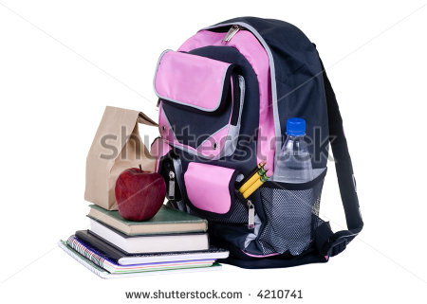

Complete the two worksheets E1 and E2 before moving on to the next section.

If you can think of more equipment you think you may need, make a note of it afterwards, here.

Worksheet E1 WHAT EQUIPMENT DO I NEED?

Draw a circle around the equipment that you think would be helpful to take to secondary school.

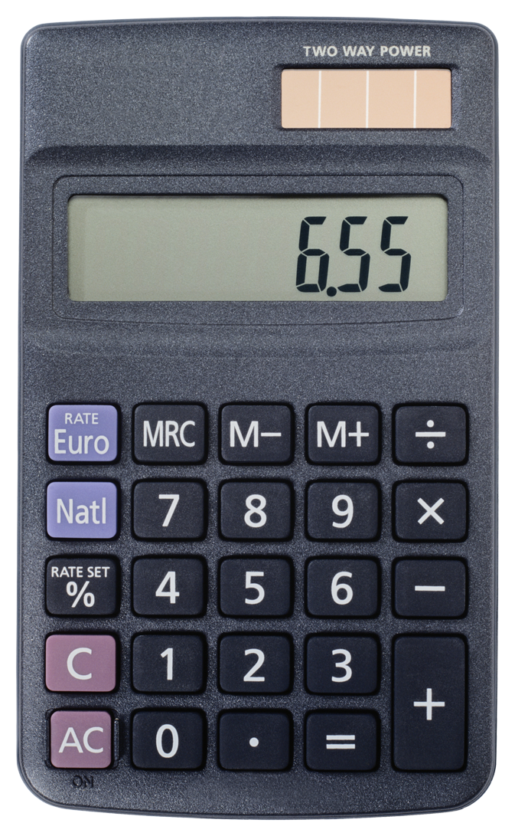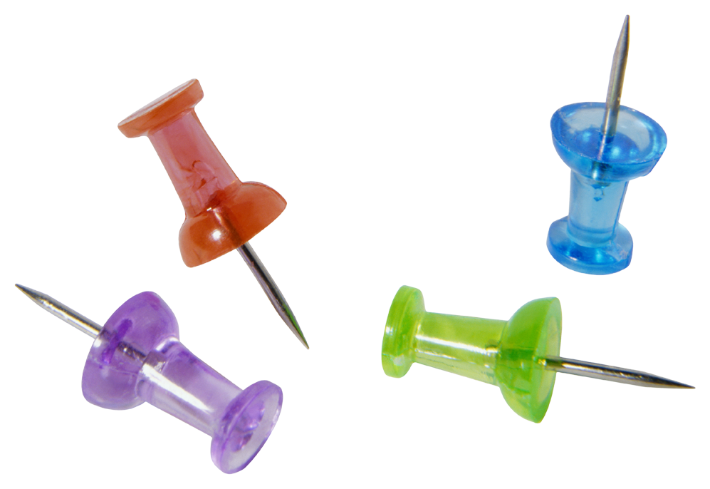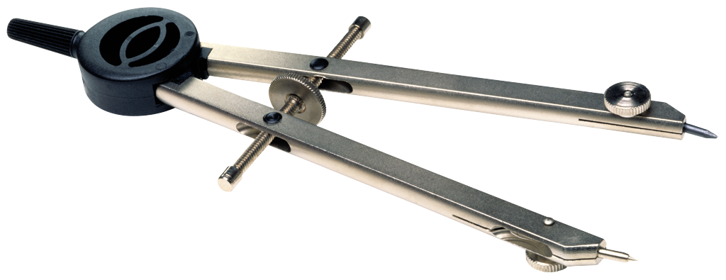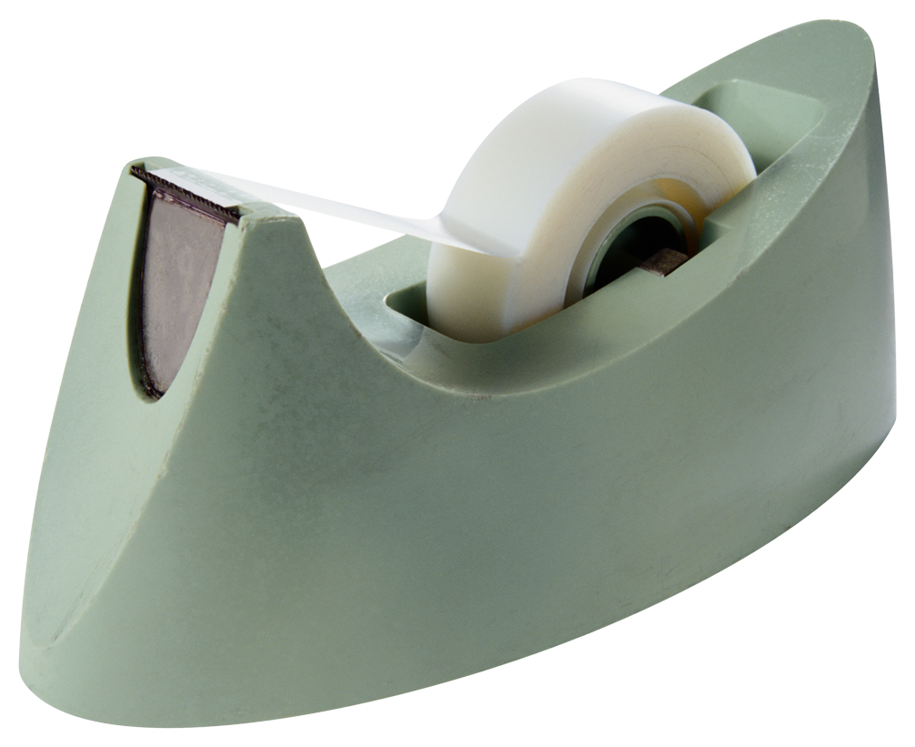

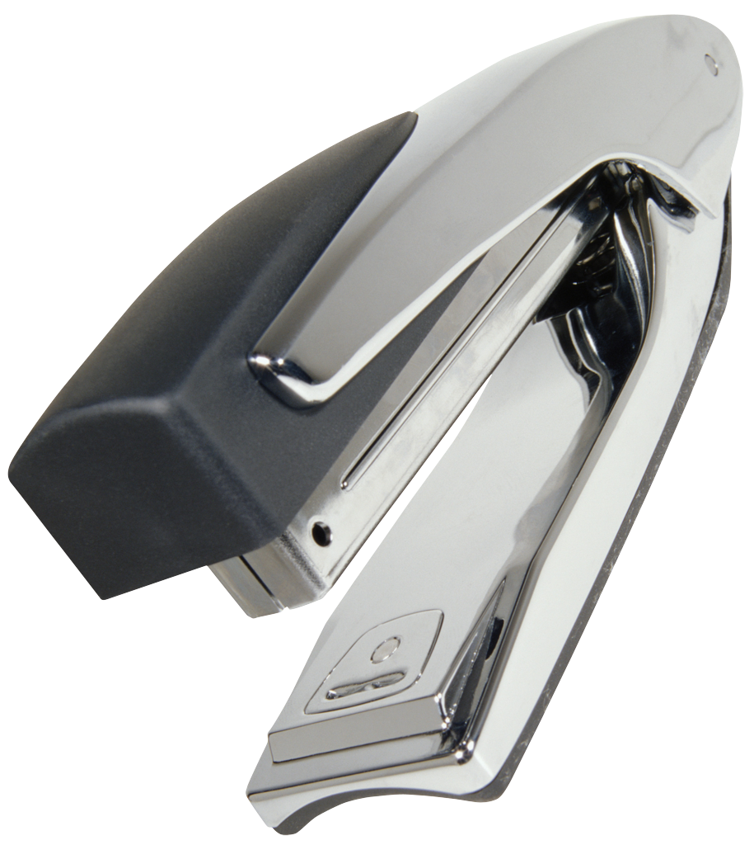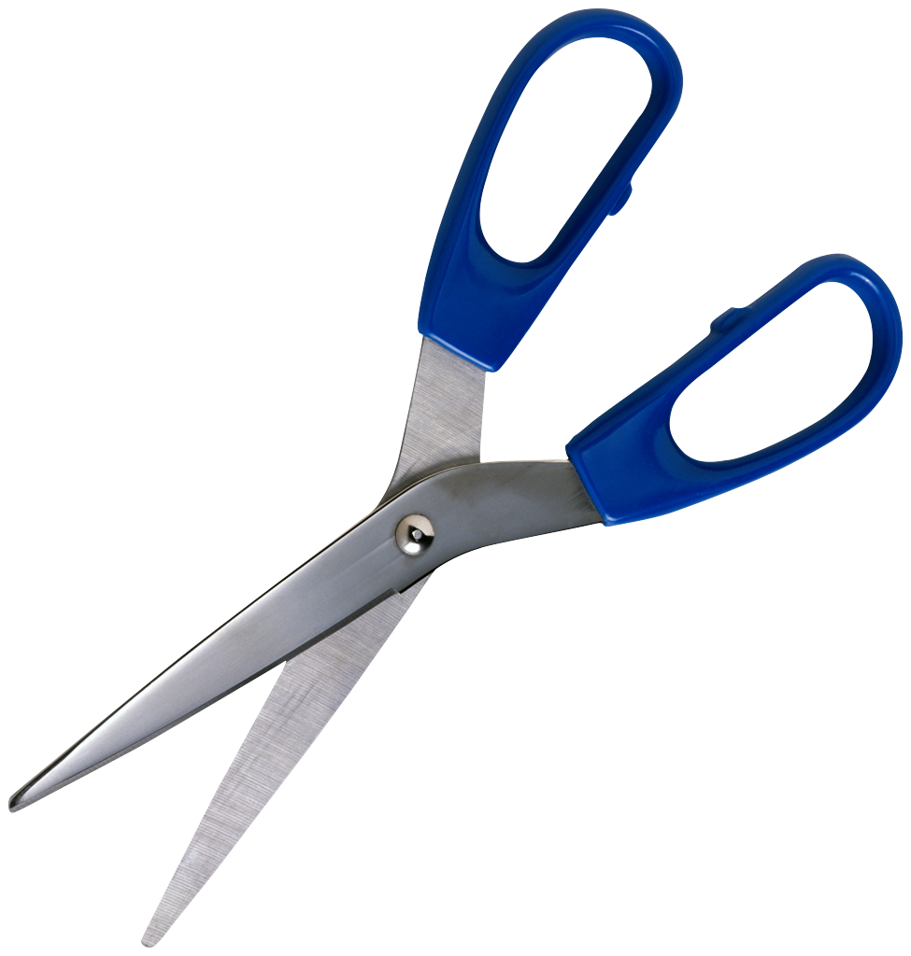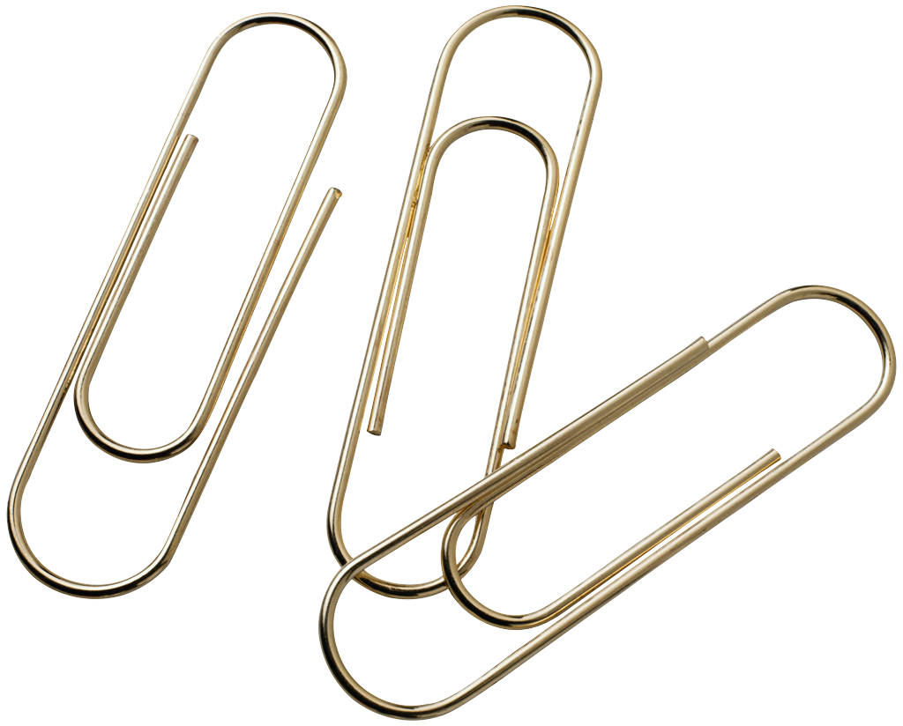

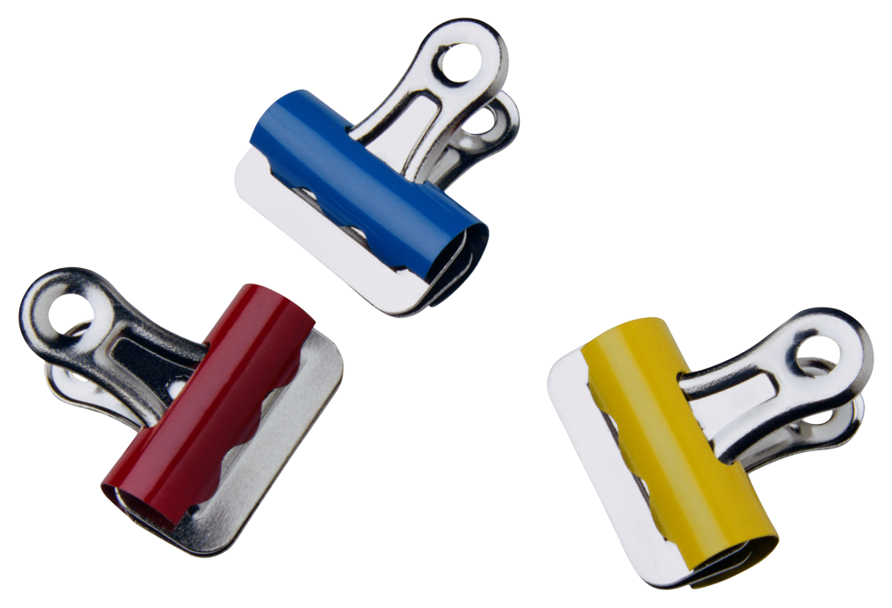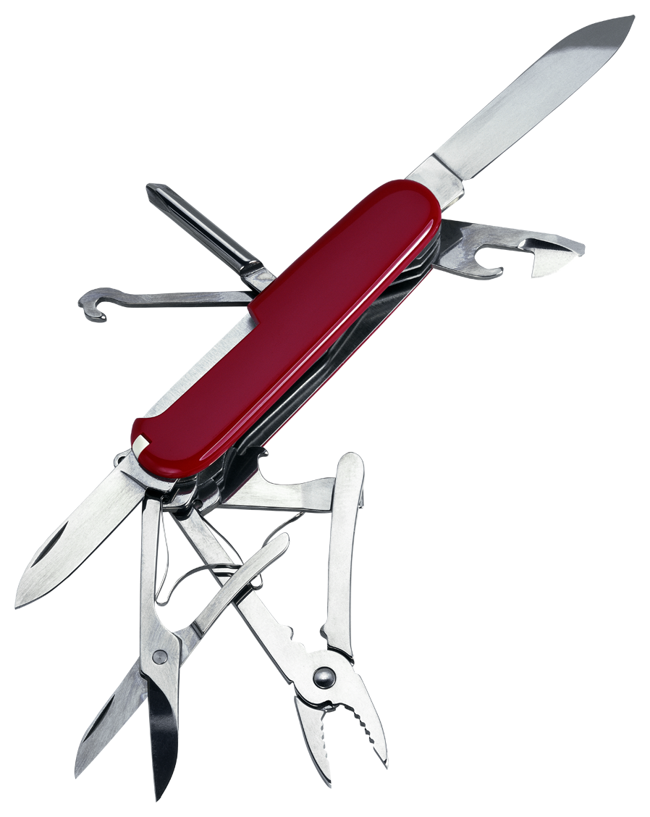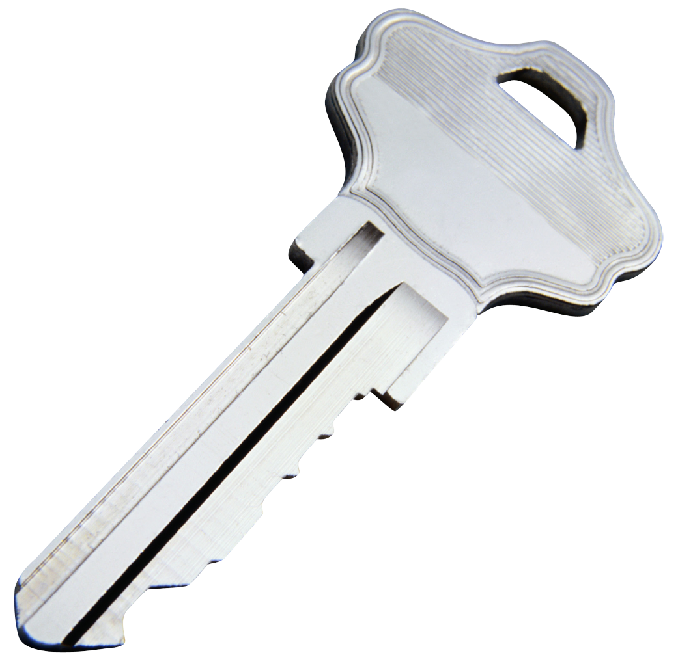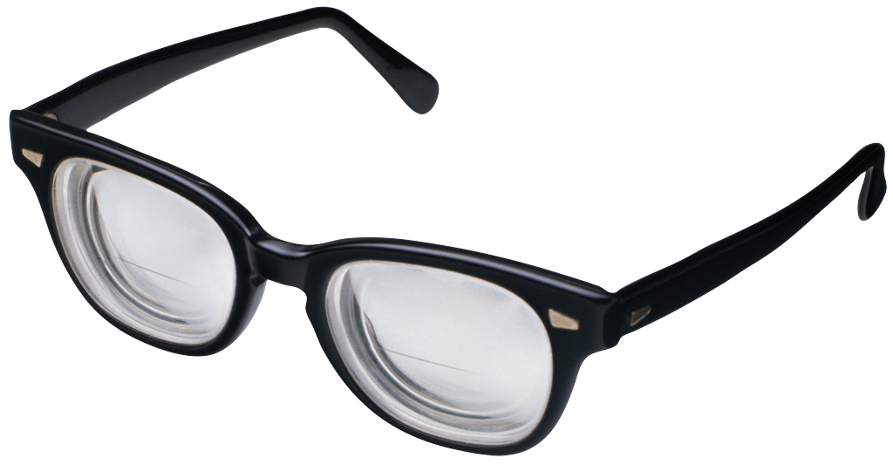


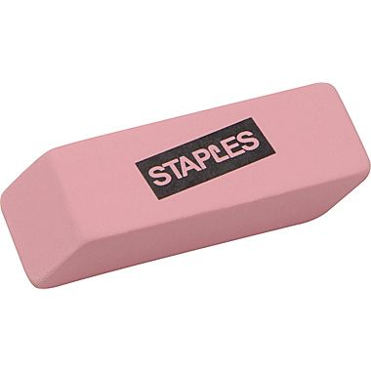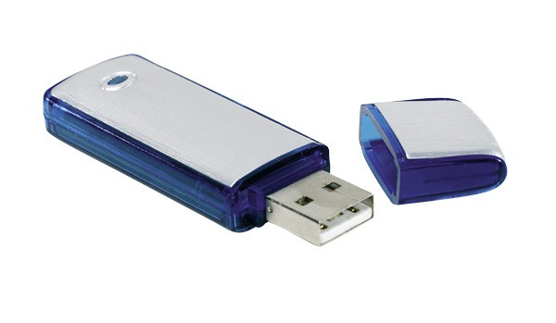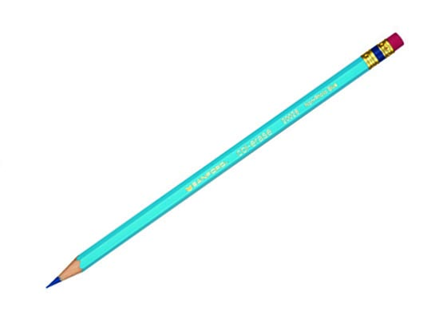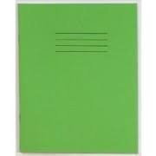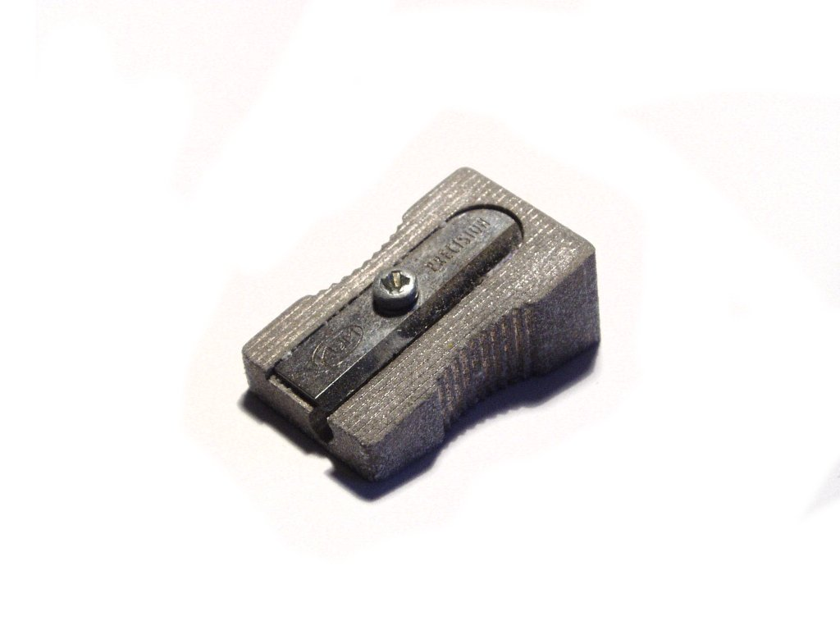

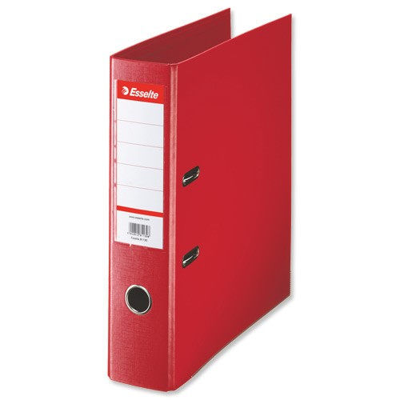

Worksheet E2
WHAT EQUIPMENT DO I NEED?

- Discuss with a friend whether or not you need all the items you have drawn a circle around on Worksheet E1
- Are there any items that you think would NOT be helpful to bring to school and why?
- Cut out those items that should be in your school bag and stick them in the bag below
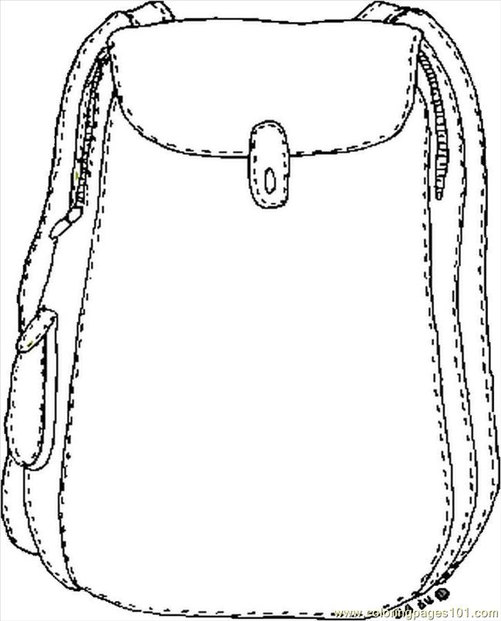
TOP TIP: it would be a good idea to pack your school bag with what you need for school the night before and leave it by the door, ready.

EQUIPMENT CHECKLIST

This is a list of some of the equipment you might be asked to bring to school.
- TICK any of the items that you already have
- CROSS any of the items that you don’t think are necessary
- Find out how much it would cost you to buy what you think you will need
- Add anything to the list that you think you may need

ITEM | or  | COST
Two pens  Ruler  Two HB pencils  Pencil sharpener  Rubber or eraser  Coloured pencils/crayons  Felt tip pens  Highlighter pen  Compass  Protractor  Dictionary  Paper clips  Stapler – small  Glue stick  Hole punch  Calculator  Ring binder/folder  Notebook  USB memory stick  TOP TIP – Look after your equipment and remember to mark all your belongings  clearly. |  | £  £  £  £  £  £  £  £  £  £  £  £  £  £  £  £  £  £  £

UNIT TWO
TIMETABLES

In your primary school you spend most of your time in your classroom with the same teacher. It is different at secondary school because you will probably have to move from classroom to classroom about every hour throughout the day. You will have different teachers for all your different subjects. Therefore, when you start secondary school you will be given a timetable and you will have to learn what is on it and where all the rooms in the school are. Don’t worry about any of those things, because there will be lots of people to help you (everyone gets lost to begin with!).
Here is one pupil’s timetable:
 | Monday | Tuesday | Wednesday | Thursday | Friday
8.45 | Tutor Time / Assembly
9.15 | Maths | Swimming | French | Geography | R.E.
9.45 | French | English | Music | Technology | Music
10.40 | Break
11.00 | Art/Design | Science | Geography | History | English
12.00 | Lunch  Chess Club Choir Practice
1.15 | Science | History | Maths | Games | Science
2.20 | P.E. | Technology | English | Maths | French
3.30 |  | Football
Homework | Science Maths | English History | Geography French | Technology Maths | English French

We will call this pupil Chris (who can either be a girl or a boy – you choose). You need to look at Chris’ timetable and work out what s/he needs to take to school each day of the week.

- Some days s/he has lunchtime or after school activity clubs which will need equipment,
- S/he also needs an old shirt or apron for Art and Design and Technology and
- A laboratory coat for Science.
- S/he will need to bring a P.E. or swimming kit to school when any sports activities are on the timetable, either in school time or after.
- S/he will also need a packed lunch for the days when there is a lunchtime club.
- Don’t forget to include homework, which needs to be handed in the day after it has been set – or straight after the weekend for that set on a Friday.

Now fill in the table below to help Chris remember what to take to school on which days (Monday has been done for you!)

Monday | Tuesday | Wednesday | Thursday | Friday
English Homework

French Homework

Old shirt or Apron (Art)

Packed lunch for Chess Club
Laboratory coat for Science
P.E. kit

TOP TIP – We have already said it is always useful to pack your school bag the night before so you have time to check you haven’t forgotten anything.

Another TOP TIP – Don’t forget to ask your mum to wash your sports kit if it needs it – don’t expect her to remember: it’s your kit!
TIMETABLES: MY TIME

How do you spend your time at the moment? Choose a day of the week when you are at school and colour in the pie chart below according to how you spend your time. The pie chart is divided into 24 hours and your day will start at about 7 or 8 o’clock in the morning when you get up.
Colour in green the time you are at school (from about 9 until 3.30)
Colour in red any time you spend at clubs or after school activities
Colour in yellow any time you spend doing homework and
Colour in blue the time you spend asleep
What do you do the rest of the time? Share your answers with a partner.
What do you notice?

PIE CHART TO SHOW HOW I SPENT MY TIME

24

12

MY TIME

Now make a timetable for your day (using the information on the pie chart).
Think about what you get out of each activity (what are the benefits?).
(Here are some to help you get started. You don’t have to use all the lines)
Put the information into the timetable below:

Time | Activity | Benefit | Home (H) or School (S)
07.00 | Get up – have breakfast | Keep healthy | H
09.00 | School | Learning/fun | S

Now do the same thing for one day at the weekend – is it very different?

TOP TIP
Always make sure you make time to do your homework at the earliest opportunity, don’t leave it until the last minute, it might take longer than you think!
TIMETABLES: GET ORGANISED!
It’s okay sorting your timetable out and knowing how to spend your time but you have to be organised and that’s all about LISTENING, UNDERSTANDING and then TAKING TIME to do things in the RIGHT ORDER.

Joe (or Joanne if you prefer) got really mixed up with the work and needs your help to sort it out. The class were told to design a DVD case in the Technology lesson and Joe just didn’t get organised – can you put things in the right order? Cut out the sentences below and put them in the order they need to be done in.

Joe writes down his homework task in the lesson.

At home, Joe puts the finished work carefully in his bag.

Joe carefully reads the instructions and begins by measuring the DVD

Joe’s DVD case has a bit sticking out. He asks the teacher for help.

Joe listens as the teacher tells the class what will be happening in the lesson

Joe hands his homework in on time.

Joe designs his case.

Joe uses the notes he made in the lesson to finish his homework.

Joe makes his DVD case.

Joe reads the teacher’s comments at the bottom of his homework.

Joe corrects the mistakes that the teacher marked.

UNIT THREE
LOTS OF TEACHERS

At Primary school you probably only had one class teacher, but there would have been other people who came in to help or to teach specific things like Music or French. In secondary school you will have a FORM TUTOR but you will only see them for a short while each morning. Each subject at secondary school is taught by a ‘SUBJECT SPECIALIST’, so you will have lots of different teachers each day. These teachers may only see you once or twice a week and therefore they will take longer to get to know you, and it is likely that you will like some better than others. They will all have different approaches and different expectations of you and your work. They may even expect you to do things differently in each lesson. You might find this hard and confusing but let’s meet some of the teachers at an imaginary secondary school:

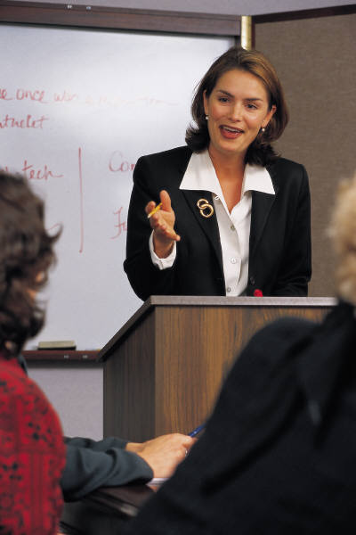
Mrs. Aider is the head of Year 7. She works with all the Year 7 tutors and knows all the pupils in Year 7. She visited all the primary schools and met each pupil before the new term began. She welcomed everyone on the first day. She is happy for pupils to come and talk to her about school, work, friends or home and her door is always open.



Mr. Chatterton is an English teacher who does lots of project work. He likes pupils to work together and be responsible for their own work. He marks everything in class, discussing work with each pupil. He does not allow pupils to chat about anything other than their work in his lessons.


Mrs. Crosslands is a Science teacher who expects all her pupils to work hard. No one is allowed to mess around in the laboratory, as it is too dangerous. She expects all her pupils to listen carefully and work quietly. If anyone hands their homework in late, she gives them detention.


Miss Young is the tutor of 7C. She has a sense of humour and always has time for her pupils. She encourages pupils to talk to her about any problems, and so can parents. She checks pupils’ diaries once a week and talks to the subject teachers about her class. She always tells the class that she was a pupil not long ago and knows how they feel


Mr. Quick is the PE teacher and insists that pupils must have all their PE kit. He won’t accept any excuses for missing games and is great fun if you like sport. He runs the after-school training, and organizes the school sports day and football matches against other schools. He is a very good athlete and expects all his pupils to make an effort.



Mr. Tuadtu teaches maths. He expects his pupils to listen and do as they are asked immediately. He likes mental maths and logic games and runs the chess club. He insists that the maths books are neatly presented and that homework is handed in on time.

These teachers all have very busy lives with lots of things to do as well as teaching. Mr. Tuadtu, for example, is doing an MA in Special Needs and he is also Head of Department. It might help you understand if you have a look at Mr. Tuadtu’s diary to see what he does in just one week:

Look at Mr. Tuadtu’s diary and his teaching timetable on the next page and then answer the questions that follow:
Mr. Tuadtu’s Diary
MONDAY  12.30 Chess Club | Collect kids from after school club | Marking and lesson planning
TUESDAY  Break Duty a.m. | Homework Club 5 pm | Marking  8.30 Cinema
WEDNESDAY  10.40 (break) see Colin 9S needs help with fractions | 4.00 School Show rehearsal | Read notes for staff meeting tomorrow and prepare statistics for Departmental Heads meeting
THURSDAY  Departmental Heads meeting 11.00 – exam statistics | 1.15 See Parent – Julie 11C re: amanuensis | 3.30 Staff Meeting  6.00 – 9.00 SEN course (M.A.) Nottm. Trent Uni.
FRIDAY | Phone Science Centre to finalise trip arrangements  3.30 Detention Duty | Marking A level Maths project work
SATURDAY  ‘A’ level Science trip | Shopping for present and food shopping | Sue’s Birthday Party 8 pm
SUNDAY  LIE IN! | Writing reports  Lunch at Mum’s  Remember to find book for Darren in 11C | Planning and Preparation for week ahead

Teaching Timetable – Maths (Mr. Tuadtu)
 | Monday | Tuesday | Wednesday | Thursday | Friday
8.45 | Tutor Time / Assembly
9.15 | 7C | A level Maths | 8D | A level | FREE
9.45 | 9S | A level Maths | GCSE 11C | 9S | 8D
10.40 | Break
11.00 | 8D | 9S | 7N | Dept. Heads | 7N
12.00 | Lunch  Chess Club
1.15 | GCSE Maths 11C | GCSE  Maths 11C | 7C | FREE | A level  Maths
2.20 | GCSE Maths 11C | GCSE  Maths 11C | 7N | 7C | A level  Maths
3.30 |  | Homework club 5 pm | Rehearsal  4 6 pm | Staff Meeting | Detention  Duty
A week in the life of Mr. Tuadtu:

1. How many maths lessons does Mr. Tuadtu teach in a week?

2. How many different classes does he teach in one week?

3. If there are about 25 pupils in each class, how many pupils does he teach in one week?

4. What else does Mr. Tuadtu do for his pupils apart from teaching lessons and marking their work?

5. When does Mr. Tuadtu prepare his lessons?

6. When does he mark the work that his pupils do in lessons and for homework?

7. If you are late handing in your homework in (it is due in on Tuesday and Friday morning) when do you think Mr. Tuadtu will have time to mark it?

8. How do you think he would like you to behave in his class?

9. Do you think he enjoys all the things he has to do during the week or are there somethings he would rather not do?

Now that you have ‘met’ these teachers work in pairs or small groups to answer these questions:

- Who would expect the class to be quiet in lesson time?
_________________________________________________
- Who would you talk to about a problem at home?

_________________________________________________

- Which teacher would you know best?

_________________________________________________

- Who would you talk to about a problem with the P.E. lesson

_________________________________________________

- Who do you think you would like best? Why?

_________________________________________________

_________________________________________________

- If you had Science and Maths homework on the same day, which would you do first?

_________________________________________________

- What do you think you could do to get on well in the science class?

_________________________________________________

_________________________________________________

- Look at the description of Mr. Chatterton, what could you do to get on well in his class?
_________________________________________________
_________________________________________________
_________________________________________________

- Do you think that you and your class would behave in the same way with all the different teachers?

____________________________________________________

Why?

- How are these teachers different from your teachers in primary school? (list as many things as you can)

PRIMARY | SECONDARY

WHOSE JOB?

We have been looking at the different things that teachers do in school – they are all there to help you learn and they all do it differently. Now we need to think about what you want from your teachers. Look at the list of things below, there are some things that it would be appropriate to ask your teachers to do – some that your tutor could do and some that maybe you wouldn’t want a teacher to do at all.
Help you make decisions | Leave you alone | Lend bits of uniform if you forget it
Keep order in class | Get you to join clubs | Talk to you parents
Talk about last night’s TV with you | Help with your homework | Run clubs
Organise sports fixtures | Be strict | Cheer you up
Sort out arguments and disagreements | Give you a lift home | Tell jokes
Show you how to use the library | Write your report | Be a friend
Help you learn things | Teach you about drugs | Make you feel good
Lend you money | Help you when you don’t understand something | Be kind
Listen to you | Help you organise your work | Remind you about things

WHOSE JOB?

Cut out the boxes on the last sheet and stick them into the chart below in the appropriate column. If you want to add some of your own ideas please do. Collect those things from the list that you don’t think are a teacher’s job and stick them on the next page.

Your Form Tutor | Subject Teacher | Head of Year

WHOSE JOB?

Those things that aren’t really a teacher’s job should be stuck here. Maybe you can decide whose jobs they are and write it by the side (it might be your friend, your mum/dad, brother, or someone else – or even you!

UNIT FOUR
NEW BEGINNINGS

Starting a new school is both exciting and a little worrying, but everyone feels the same, even if they don’t admit it. This is an opportunity for you to make new friends – people you haven’t met yet – and keep old friends.

FEELINGS!

Here are some words describing how some people may be feeling on their first day at a new school:

Exhilarated Scared Happy

Frightened Anxious Excited

Unhappy Bewildered Confused

Rushed Tired Busy

Worried Okay! Stressed

Put a circle around how you think you might be feeling on your first day.
Can you think of any other words that would describe your feelings? You might need to use a dictionary or thesaurus

Most people get worried or anxious about new situations, even if they are looking forward to them and are excited. After a few weeks they wonder what they were worrying about because once we get used to something we all cope with it better. How you feel about it today will change when your first day at secondary school arrives, and it will change again when you have been there for six weeks

Now complete the worksheet about your feelings which is on the next page. Think of a word to describe how you feel about the situations described. Complete the first column (Now) for each of the situations, before continuing with the next column (First Day) and then the last column (Six weeks later).

How do you feel about . . .


 | Situation | Now | After your transition visit | At the end of September
1 | Finding your way around the secondary school
2 | Not being in the same class as your best friend
3 | Getting to school on time
4 | Going to different classrooms with different teachers each lesson
5 | Reading a timetable
6 | Having homework to complete every day
7 | Being in a class with a lot of people you don’t know
8 | Remembering to bring the right kit and equipment to school each day
9 | Remembering your new teachers names
10 | Learning new subjects

WHAT CAN I DO TO MAKE THE FIRST DAY OKAY?

In your group discuss some of the things that you could do to you’re your first day at your new secondary school go well. For example, you could arrange to meet a friend to go to school together.

There are also things that you should NOT do, for example, it wouldn’t be a good idea to be late on your first day. You might also discuss why certain things would be a good or bad idea.

After you have discussed the DOs and DON’Ts fill in the table below:

 | Things to do | Things NOT to do
Before school starts
On the first day in the school

NEW FACES and NEW FRIENDS

One of the really good things about secondary school is that you will get the chance to meet lots of new and different people. If you ask some adults they will tell you they met their best friend at secondary school! You are growing up and making choices of your own, and new friends will be part of that. Often the first year of a secondary school will bring together the children from five, or even more, primary schools, so you will have lots of people to choose from.

Think about the friends you have now. Sometimes people become friends because they are in the same place (school), or do the same activities (swimming), or even because their parents were already friends. Can you remember how you became friends or how and where you first met?

Write a list of the things that you really like about your special friends:

What I like about my friends:

Discuss in your group what it means to be a friend and then complete the sentence below:

A friend is someone who . . .

You are going to make new friends in your new school. In your group try and work out some of the things you can do make new friends, then make a list of them:

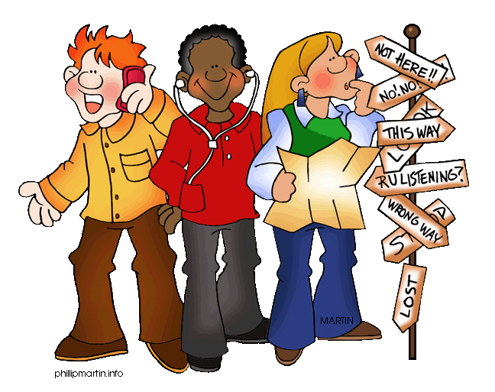

TOP TIP:
Remember, first impressions are important. SO SMILE and BE NICE.
FALLING OUT + MAKING UP
One of the best things about real friends is that you stay friends! There is no reason why you should loose touch with any of the friends you have at primary school, even if they go to different secondary schools – you both just have to make the effort.

Even when we have friends, sometimes we might disagree with them, argue or fall out. Complete the questionnaire below by putting a circle around your choice of answer:

- Do you thing that you argue with people a lot?
  - No, I don’t argue
  - Sometimes
  - Often
  - Depends who it is

- Do you ever start an argument just because you feel like it?
  - Yes
  - No
  - Sometimes

- Do you enjoy arguing with people?
  - Yes
  - No
  - Sometimes

- When others are arguing what do you do?
  - Try to stop them
  - Let them get on with it
  - Ask someone to stop them
  - Enjoy watching/listening
  - Join in

- Do you think that you are an argumentative person?
  - Yes
  - No
  - Sometimes

- Do you think that other people think that you are argumentative
  - Yes
  - No
  - Sometimes

- Who do you argue with most?
  - Parents
  - Teachers
  - Brothers/Sisters
  - Friends
  - Someone in particular
  - Anyone

- When you argue with a friend do you . . .
  - Storm off
  - Sulk
  - Hit them
  - Cry
  - Something else

- What do you argue about?
  - Other people
  - Your opinions
  - What they/you have said
  - What you are going to do
  - Cheating
  - Lying
  - You being hurt
  - Something else

- When you argue are you ever rude to the other person?
  - Yes
  - No
  - Sometimes
  - Often

- How do you feel if someone is rude to you when you are arguing?
  - I get angry
  - I get upset
  - I feel like crying
  - I feel like hitting something/someone
  - I feel like running away
  - I don’t care

- If someone apologises and says they are sorry to you, do you
  - Say ‘That’s okay’
  - Say ‘I’m sorry too’
  - Refuse to make up
  - Ignore them
  - Still feel hurt/angry

- Do you ever say you are sorry?
  - No
  - Sometimes
  - Often
  - All the time

- Whose fault is it when you get involved in arguments?
  - Someone else’s
  - My fault
  - Their fault
  - Our fault
  - Nobody’s fault

- Would you prefer not to get into an argument?
  - Yes
  - No
  - Don’t mind

Now share your answers with your group and see if you can agree on some ways people can reduce the number of arguments and falling out.

FRIEND or FOE?

Sometimes, when arguments get out of hand people are accused of bullying. Every school (primary and secondary) has an Anti-Bullying Policy, and if you feel you are being bullied, or you know someone who is, don’t stand by and let it happen – tell an adult. Tell your parents/carers, your tutor, your Head of Year or any adult in school – they will all listen and will all want to help.
There are many kinds of bullying, such as:
Name calling
Spreading rumours and untruths
Leaving someone out
Cyber bullying (posting things on line – Facebook, etc.
Physical assault
Making threats
Extortion
and more.

You may have heard stories of people being bullied at secondary school, and you have probably taken part in a D.A.R.E course at primary school.
You can help yourself too by NOT being passive, NOT being aggressive, but by being assertive – often if you stand up to a bully they will back down.

WHICH CREATURES ARE YOU MOST LIKE?

Match the descriptions below to one of the three creatures: mouse, shark or bear. Put a circle around the right answer:

1. It is AGGRESSIVE and will attacks most things, not just because it is hungry or afraid

MOUSE SHARK BEAR

2. It is PASSIVE, scared of most things, including movement and noises. It will run away and hide itself at the first opportunity.

MOUSE SHARK BEAR

3. It is a clever animal and prefers to be left alone, unless it is provoked when it can stand up for itself and become very ASSERTIVE.

MOUSE SHARK BEAR

Look at these cartoon drawings of the three creatures - which of the descriptions on the last page best describes how you behave?


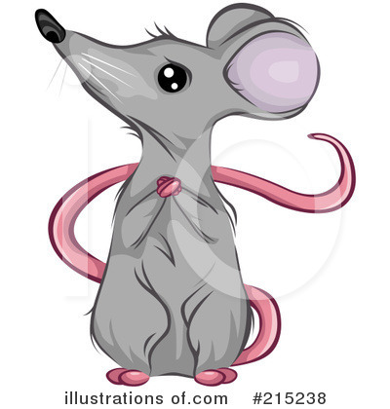



Draw a circle around the one that you behave most like when faced with a conflict.

ROLE PLAY
Your teacher will give you a SITUATION CARD for you and your group to act out. You will have to act it out being AGGRESSIVE or ASSERTIVE (your choice) whilst the class watches. They will have to guess which behaviour you are acting out and then you will do it again, acting in an ASSERTIVE manner (which is always the best way of dealing with the situation).

Assertiveness...what am I like at it?

Fill out the questionnaire below. Look at your answers and talk to your partner about how you can both improve.

 |  | Never  Good | Not very  Good | Quite  Good | Very  Good
1 | Expressing feelings  I’m not very . . . happy
2 | Standing up for yourself
3 | Making suggestions  Can I suggest . . . that
4 | Refusing  NO, I don’t want to!
5 | Disagreeing  I don’t agree…
6 | Complaining  This soup is cold
7 | Apologizing  I’m sorry
8 | Requesting explanations
I’m not going to do that want to do that . . .
I don’t understand

NEW BEGINNINGS – WHY IS SCHOOL SO IMPORTANT?

How well you do at secondary school will depend on the choices you make. Those people who do well know why they go to school, and know what they want to do when they leave school and become an adult. Do you?

Here are some of the reasons we go to school, you might be able to add some more of your own. Cut out the reasons below and put them in order of importance

To make new friends | To learn more about things | To pass exams | To play sports
To be looked after whilst mum is at work | To know what is healthy | To work with other people | To learn to share
To learn life skills | To share your knowledge | To find a boy/girl friend | To socialise with your friends
To learn new skills | To find out what you can do | To enjoy yourself | To learn to communicate well
To be able to do maths | To work things out | To have lunch | To go to clubs
To have a laugh | To use the library and other facilities | To stop you being bored | To develop new interests

What job would you like to do when you grow up? Some people your age know already, but they can change their mind, some people have no idea. Think about what you are good at, what sort of job could you do where you can use those skills. You might need to look in the library or on the internet to find out more information about different jobs, or even talk to people you know about what they do.
Whatever you decide to do you will need certain skills as an adult, things you can learn at school and practice and get better at during your school life.
You might already be quite good at some of them.
Writing | Reading | Spelling
Listening | Speaking | Logical thinking
Adding up and taking away | Exercising | Organisational skills
Being on time | Planning | Co-operation skills
Concentration | IT skills | Design skills
Being good at making things | Thinking skills | Social skills
Being quick | Prioritisation skills | Being good at remembering things
Being reliable | Trustworthiness | Being optimistic
Co-ordination | Multi-tasking | Finishing things off

Can you think of any more to add?
Colour in the TEN things you think are most important to help you get on well at your new school.
DECISION MAKING

You and your parents have made a big decision about which secondary school you are going to in September. As you grow up, more and more people will expect you to make decisions for yourself. When you get to secondary school you will have to decide what to choose for your lunch (and how much to spend), when to do your homework, etc. Making decisions can be hard, but if you follow some simple steps they can get easier:

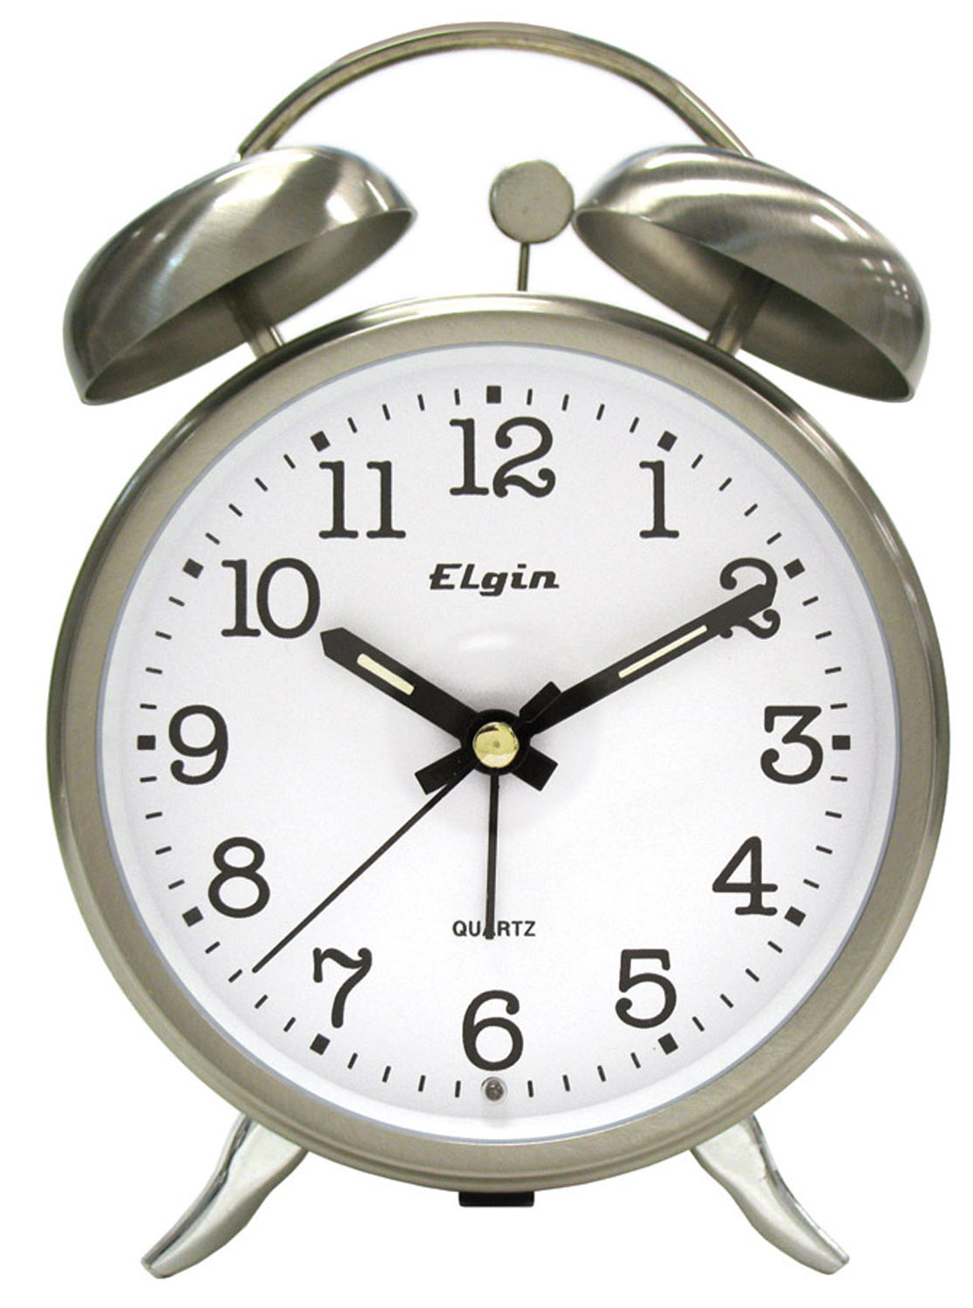

- Before making a decision, take your time


- Stop and THINK – give your brain chance to get in gear



3. So that it can weight up things

BEFORE . . .
so that YOU make the RIGHT DECISION

On the next page there are some situations – can you make a decision? Put a circle around the letter next to the answer of your choice and then share your answers with your partner. Make sure you know WHY you made that decision!

YOU DECIDE!

- You are stuck on some work in the classroom – would you:
  - Guess the answer
  - Leave it and go onto the next question
  - Put your hand up for help
  - Go up to the teacher to ask for help
  - Copy off someone else
- There are two after school clubs you really want to join but they are both on the same night – what do you do?
  - Choose the one that your friends are going to
  - Don’t go to either
  - Do them both – a different one each week
  - Find out if they run either of the clubs on a different day
- You have a lot of homework to do this evening but your friend has asked you to go to the cinema – would you:
  - Go and leave the homework
  - Leave it until tomorrow break time and do it quickly
  - Do it properly as soon as you get in so you can go to the cinema later
  - Ask your brother/sister/mum/dad/auntie, etc. to do it for you
- Your journey to school takes 25 minutes if you walk, would you:
  - Walk it
  - Use your dinner money to pay the bus fare
  - Run to the next bus stop which is cheap
- You didn’t do your homework last night and Mr. Tuadtu wants it in first lesson this morning, do you:
  - Tell the teacher you didn’t do it and why (because you chose to go to the cinema)
  - Ask you parent(s) to write a note explaining
  - Pretend to be ill to miss school
  - Just not go to the first lesson
Share your answers.
Can you think of any decisions you have made this week?
UNIT FIVE:
THE

GAME

For the final Unit in this series you will need to work in a team of no more that 5 children. You are going to make a TRANSITION GAME, using a large plan/map of your new school (usually on squared paper), which you will get from your teacher. The idea is that you use a dice to move around the school according to a timetable, picking up Chance, Sanction or Reward Cards, which will help or hinder your progress – the winner is the person who finishes first.

Before you start making your game you will need to collect together the resources you need and plan and agree what you are going to do. Your teacher will help by giving you blank Chance, Sanction and Reward Cards and examples of timetables, etc.

If you haven’t played many board games it might be a good idea to have a go at one or two to see how they work before you start.

You may have ideas of your own about how you want to make or develop the game you create, and that is okay too.

When your team have made the game and you have all played it to make sure it works then the whole class will have the opportunity to have a games afternoon where you can play some of the other games that have been made in your class. At the end of that session you can mark the games you have played out of 10 and see if you can agree which is the best one. You will have to take into account how well it is made, how professional it looks and how exciting it is to play.

There is only one thing left to do, and that is to wish you lots of success in your new school,
and to let you know that if you have any questions, worries or problems
your teachers are always there to help.

