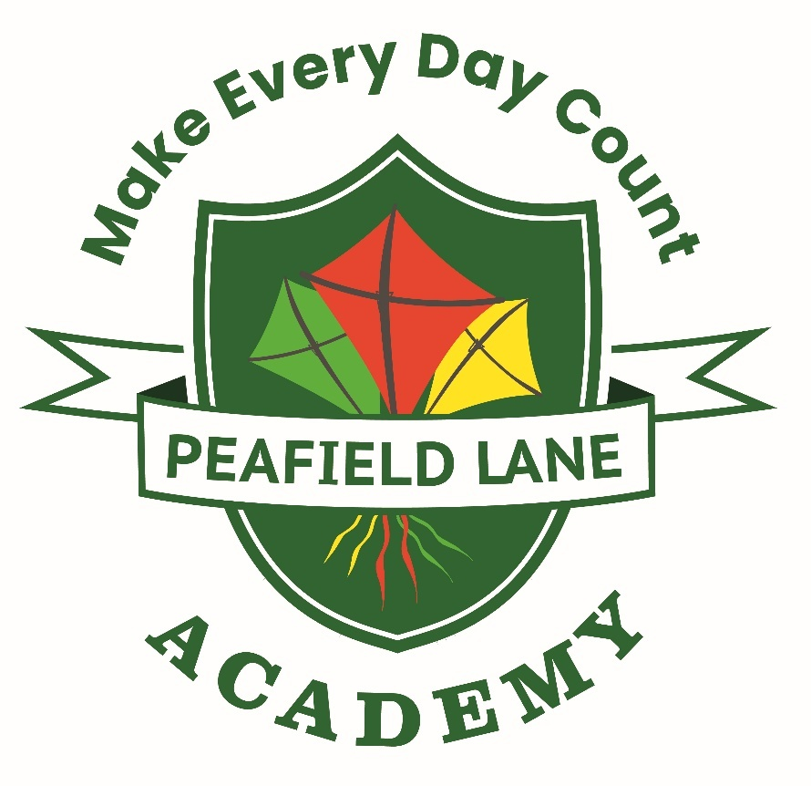

Equality Policy

Date Policy Adopted | January 2026
Date Policy to be Reviewed | January 2027
Date Presented to Governors | January 2026

EQUALITY STATEMENT
Legal Duties

At Peafield Lane Acamdey, we welcome our duties under the Equality Act 2010. The general duties are to:

- eliminate discrimination,
- advance equality of opportunity
- foster good relations

We understand the principal of the act and the work needed to ensure that those with protected characteristics are not discriminated against and are given equality of opportunity. Protected characteristics make up the part of a person’s identity that makes them who they are, such aspects or characteristics are protected from discrimination. Everyone in Britain is protected from unlawful behaviour by the Act.

The protected characteristics are as follows:

- age
- disability
- race
- sex
- gender reassignment
- maternity and pregnancy
- religion and belief
- sexual orientation
- marriage and civil partnership (for employees)

We recognise that these duties reflect international human rights’ standards as expressed in the UN Convention on the Rights of the Child, the UN Convention on the Rights of People with Disabilities, and the Human Rights Act 1998. In developing our policy, we have therefore also taken them into consideration.

To meet our general duties, listed above, the law requires us to carry out some specific duties to demonstrate how we meet the general duties.
These are to:

- Publish Equality Information – to demonstrate compliance with the general duty across its functions (We will not publish any information that can specifically identify any individual)
- Prepare and publish equality objectives which we will review on an annual basis

- Consult all our stakeholders in the development of our equality objectives and report on progress against our objectives on an annual basis

To do this effectively we will collect data related to the protected characteristics above and analyse this data to determine our focus for our equality objectives. The data will be assessed across our core provisions as a school, but we will also analyse available data relating to the context of our local community, including hate crime data and demographic information. In relation to school provision, we will pay particular attention to the following functions:
- admissions
- attendance
- attainment
- exclusions
- prejudice-related incidents
- curriculum
- complaints/compliments

Our objectives will detail how we will ensure equality is applied to the services listed above, however where we find evidence that other functions have a significant impact on any group, we will include work in this area.

We also recognise that our work on equality is central to the successful promotion of fundamental British values, especially in relation to the values of respect and tolerance and the rule of law. We will therefore ensure that our curriculum helps to prepare pupils for life in modern Britain. We will work proactively to address all forms of prejudice and discrimination, including derogatory and discriminatory language. We will mainly do this through the delivery of our statutory PSHE / RSE curriculum. We will also utilise all other subject areas to foster positive relations and to ensure that we consciously cultivate opportunities to challenge stereotypes and support positive identity development for all our pupils. We will regularly audit our resources, displays, lesson content, and assessment processes to ensure that they meet the needs of all groups. We will scrutinise outcomes across a range of measures, analyse the results and address any identified areas of concern.

In endeavouring to fulfil our legal duties, we will:

- Recognise and respect diversity
- Foster positive attitudes and relationships, and a shared sense of belonging
- Observe good equalities’ practice, including staff recruitment, retention, and development
- Aim to identify, reduce, and remove existing inequalities and barriers
- Consult and involve widely
- Regularly review our progress

Definitions

Discrimination is unfair treatment towards another or a group of individuals who share one or some of the protected characteristics.

Direct Discrimination occurs when someone is treated less favourably than others because of a protected characteristic.

Discrimination by Association occurs when someone is treated less favourably because someone they are associated with, such as a friend, family member or carer, has a protected characteristic.

Direct Discrimination by Perception occurs when someone is treated less favourably because someone believes they have a protected characteristic, regardless of whether their perception is correct or not.

Indirect Discrimination can be more difficult to identify and sometimes is not intended. It can occur due to a lack of understanding of the law or a genuine error of judgement about an individual. For example, a policy that is applied to all individuals equally may inadvertently disadvantage individuals or groups who have a protected characteristic. It is therefore essential that all aspects of school life and policies are scrutinised carefully to avoid any unlawful provision, criterion, or practice.

Victimisation occurs when an individual has either raised a complaint or grievance that they have been discriminated against based on having a protected characteristic; or has supported someone who has raised a complaint or grievance.

Harassment is any form of unwanted behaviour intended to violate an individual’s dignity or create an environment which may be described as hostile, degrading, humiliating or offensive. The victim will be subject to this harassment based on a protected characteristic or the perception that they have a protected characteristic, or because they are associated with someone who has a protected characteristic.

Prejudice can be conscious or unconscious and involves stereotypes, prejudgements, and beliefs (which are usually negative) about an individual, or group of people, based on a protected characteristic.

Our ethos/mission statement

At Hucknall Flying High Academy we recognise the importance of a positive approach to the behaviour of pupils in school. We recognise that bullying can have a devastating effect on individuals as it can be a barrier to their learning and have serious consequences for their mental health. We recognise that bullying which takes place at school not only affects their childhood but can have a lasting effect on their lives, well into adulthood.

We understand that the first and most important educators of pupils are their parents/carer and therefore recognise and value their support with regards to their child’s readiness to learn and recognise that we must work closely with them to ensure collectively we have common goals and approaches to tackling bullying. We believe that pupils make the best progress when home and school work together.

As a school we feel it is important to promote a safe, secure and stimulating environment to allow all members of the school community to feel secure, respected and therefore
promote good behaviour in others.

Roles and Responsibilities

We believe that promoting Equality is the whole school’s responsibility.

School Community | Responsibility
Governing Body | Involve and engage the whole school community in identifying and understanding equality barriers and in the setting of objectives to address these.  Monitor progress towards achieving equality objectives.  Publish data and publish equality objectives.  Ensure that staff have access to appropriate training and resources.
Head Teacher / Principal | As above including:  Promote key messages to staff, parents, and pupils about equality and what is expected of them and can be expected from the school in carrying out its day-to-day duties.  Ensure that all in the school community receive adequate training to meet the need of delivering equality, including pupil awareness.  Ensure that all staff are aware of their responsibility to record, report and respond appropriately to prejudice-related incidents.
Senior Management Team | To support the Head / Principal as above  Ensure fair treatment and access to services and opportunities.  Ensure that all staff are aware of their responsibility to record, report and respond appropriately to prejudice-related incidents.
Teaching Staff | Help in delivering the right outcomes for pupils.  Uphold the commitment made to pupils and parents/carers on how they can be expected to be treated.  Design and deliver an inclusive curriculum.  Record, report and respond appropriately to prejudice-related incidents.
Non -Teaching Staff | Support the school and the governing body in delivering a fair and equitable service to all stakeholders.  Uphold the commitment made by the Head Teacher/Principal on how pupils and parents/carers can be expected to be treated.  Support colleagues within the school community.  Record, report and respond appropriately to prejudice-related incidents.
Parents/Carers | Take an active part in identifying barriers for the school community and in informing the governing body of actions that can be taken to eradicate these.  Take an active role in supporting and challenging the school to achieve the commitment given to the school community in tackling inequality and achieving equality of opportunity for all.  Uphold the commitment made by the Head Teacher on how pupils and parents/carers, staff and the wider school community can be expected to be treated.
Pupils | Support the school to achieve the commitment made to tackling inequality.  Uphold the commitment made by the Head Teacher on how pupils and parents/carers, staff and the wider school community can be expected to be treated.  Report prejudice-based incidents to a trusted adult.
Local Community Members | Take an active part in identifying barriers for the school community and in informing the governing body of actions that can be taken to eradicate these  Take an active role in supporting and challenging the school to achieve the commitment made to the school community in tackling inequality and achieving equality of opportunity for all.

We will ensure that the whole school community is aware of the Equality Policy and our published equality information and equality objectives by publishing them on our school website.

Preventing and Addressing Prejudice Related Incidents

We define prejudice-based incidents/bullying in the following way:

Prejudice-related incidents/bullying – derogatory and discriminatory language and behaviour including that which is racist, sexist, homophobic, biphobic, transphobic and disablist in nature. This language and behaviour may be directed towards people because of their sex, religion or beliefs, race/ethnicity/nationality; or because they have a learning or physical disability; or because they are lesbian, gay, bisexual, or trans, or are perceived to be, or have a parent/carer, sibling, or friend who is. It may include misogyny or misandry and be sexist in nature. Such language and behaviour are generally used to refer to something or someone as inferior.

At Peafield Lane Academy, we encourage open discussions around differences between people, we actively challenge prejudice, and we celebrate diversity. This school is opposed to all forms of prejudice, and we recognise that children and young people who experience any form of prejudice- related discrimination may fair less well in the education system. We recognise that prejudice-based and discriminatory bullying is a form of child-on-child abuse and is therefore a safeguarding concern, as outlined in Keeping Children Safe in Education 2025. We adopt a contextual safeguarding, trauma-informed and strengths-based approach to bullying and child-on-child abuse. We are committed to working with families and outside agencies to proactively prevent incidents and to create an environment in which all members of our school community feel welcomed, accepted, and safe. We believe every member of our community should be treated with respect and should not be subjected to prejudice or discrimination in any form. This includes pupils, staff, parents/carers, governors/trustees, and visitors to our school.

We provide both our pupils and staff with an awareness of the impact of prejudice to prevent any incidents. We will endeavour to proactively tackle all forms of prejudice by ensuring our curriculum is representative of all sections of society and the contributions made by people with different characteristics are consciously embedded across all subjects. In doing so, we will challenge stereotypes and work towards inclusivity and identity-safe classrooms where everyone feels validated, accepted, safe and a sense of belonging.

If incidents still occur, we will address them immediately ensuring that appropriate levels of support are provided to those affected; that we thoroughly investigate all reports/allegations; and that we will apply appropriate sanctions and address offending behaviours through a programme of education. All adults in our school community are expected to comply with the school’s Code of Conduct. Any allegations made against staff will be investigated in line with our policies and procedures relating to staff conduct and behaviour. Any staff member/parent/carer, governor/trustee or visitor to the school, who is subjected to prejudice-based abuse can also expect to have their complaint thoroughly investigated and will be supported in accordance with their wishes.

We review our practice following each incident including what more we might do to prevent further incidents. We recognise that we must not become complacent and will regularly evaluate satisfaction levels in respect of how we have responded to any reports or concerns raised.

Children (including bystanders)
It is important to understand that a victim may not find it easy to tell staff about their abuse verbally. Children can show signs or act in ways that they hope adults will notice and react to. In some cases, the victim may not make a direct report. We recognise that in some instances another child may report on another child’s behalf. All children will know how to report concerns or incidents involving prejudice or discrimination.

We ask that all children report any concerning behaviour to a member of school staff – this can be any member of teaching or non-teaching staff, including a class teacher, a TA, the Head teacher, a lunchtime supervisor, or a member of the office team. We talk about trusted adults regularly in class and in assemblies to remind our children of who they can report concerns to. The member of staff will listen to the child and make an initial note of their concerns, they will then discuss next steps with them and reassure them that they will be supported. In line with the statutory guidance provided in Keeping Children Safe in Education 2025, we will never promise a child that we will not tell anyone about a report of any form of abuse, as this may not be in the best interests of the child. The member of staff will make a formal record of the concern/report on the school’s recording system (CPOMs/My Concern etc.) and other relevant members of staff will be alerted. The member of staff will directly alert the school’s Designated Safeguarding Lead if the report is deemed urgent or if a child is considered at risk.

We understand that some children may find it difficult to tell a member of staff about their concerns verbally, we therefore have additional reporting mechanisms in place. Our school has a worry box in each classroom where the child can put their name/a brief note about their concerns/draw a picture of their concern – these worry boxes are introduced to the children at the start of the year and children are reminded of them regularly. Our school also has a Designated Safeguarding email address – if a child feels unable to tell a member of staff about their concerns verbally, they could send an email with their concerns, and these will be followed-up/responded to by the school’s Designated Safeguarding Lead or Deputy.

Parents/carers

Whether your child is responsible for an incident or on the receiving end of prejudice-based or discriminatory behaviour, you will be directly informed by a member of staff. If your child is the victim, we will talk to you about how we will support them so that the experience does not damage their self-esteem or confidence. If they are willing and ready to talk to those responsible, we will facilitate a restorative conversation so that they feel they have been heard and their feelings acknowledged. If they do not feel able to participate in a restorative conversation, we will ask them how they want to share their feelings, and how they want to receive feedback about how we have responded. We will always work on a safety plan with them to ensure they feel safe and secure in and around school. If your child is responsible for an incident, we will provide them with an opportunity for reflection. We will take into account their developmental age and understanding, when considering what action to take, but regardless of whether they have shown any deliberate intent to hurt, we will always complete some intervention designed to educate and deepen their understanding around the impact of their words/actions. We will implement natural consequences to help the child recognise why their behaviour is unacceptable and they will be supported to identify how they can make amends for their actions. They will be encouraged to take responsibility and to participate in a restorative conversation if this is what the person they have hurt wants. We will prioritise education over punishment, as we do not believe that sanctions change hearts and minds. Where it is clear however, that a child repeatedly and with clear intention, sets out to deliberately harm another person through their use of language or behaviour, which is rooted in prejudice-based and discriminatory beliefs, our response will make clear that this will not be tolerated
We understand that parents and carers may well struggle to cope with making or receiving a report that their child has been the victim of or is an alleged perpetrator of a prejudice-based incident.

We ask that if parents/carers have concerns about their child experiencing or allegedly perpetrating any such incident, that they contact the school’s Designated Safeguarding Lead/Deputy (in person/via telephone call/via email) to explain their concerns. The Designated Safeguarding Lead/Deputy will take an initial note of the concerns but may ask to schedule a meeting to allow for more time to discuss the concerns in detail. Following the report and/or the meeting, the Designated Safeguarding Lead/Deputy will make a formal record of the report on the school’s recording system (CPOMs/My Concern etc.) and other relevant members of staff will be alerted. The Designated Safeguarding Lead/Deputy will seek advice from the police if a pupil is considered at risk.

We ask that parents/carers come directly to the school with their concerns rather than discussing them with other members of the school community in person or online.

Our school remains committed to supporting pupils and their families. We will endeavour to ensure that all parties are kept informed of progress and any developments, but we will also need to show due regard to GDPR (General Data Protection Regulations) and any ongoing investigations by external agencies where a serious incident has been reported (e.g., the incident is a hate crime). This may mean, at times, that we are not able to provide or share information or updates immediately.

If a parent/carer is not satisfied with our school’s actions, we ask that they follow our school’s complaint policy and procedures. This is available online from our school website and on request from the school office.

Staff
Our staff work closely with our children and therefore may notice a change in a child’s behaviour or attitude that might indicate that something is wrong before receiving a report from a child or a member of the school community. If staff have any concerns about a child’s welfare or are concerned that a child is displaying behaviours that may show they have been the victim of or that they are perpetrating prejudice-based abuse, they should act on them immediately rather than wait to be told.

We ask that staff report their concerns to a Designated Safeguarding Lead/directly to the Head teacher. The member of staff receiving the report will take an initial note of the concerns and will then make a formal record of the report on the school’s recording system (CPOMs/My Concern etc.) and other relevant staff members will be alerted. The Designated Safeguarding Lead/Deputy will seek advice from external agencies including the police if a pupil is considered at risk.

Breaches
Breaches to this statement will be dealt with in the same way that breaches of other school policies are dealt with, as determined by the head teacher and governing body.

Policy Development
This policy has been developed to reflect the most recent Keeping Children Safe in Education (KCSiE) Statutory Guidance (1st September 2025) and The Equality Act 2010 and subsequent guidance for schools. It was formulated in consultation with the whole school community.

This policy is available:
- Online on the school website
- On request from the school office

Links with other policies
You may find it helpful to read this equality policy alongside the other following school policies:

Policy | How it may link
Safeguarding Policy | Includes information about child protection procedures and contextualised safeguarding
Behaviour Policy | Includes details about the school’s behaviour system including potential sanctions for pupils
Anti-Bullying policy | Includes information about bullying behaviours and vulnerable groups
Online Safety / E-Safety / Acceptable Use Policies | Includes information about children’s online behaviour and details about online bullying/cyberbullying
Child-on-Child Abuse Policy | Includes links to bullying
RSHE / PSHE Policy | Includes information about our school’s RSHE programme and how we teach about healthy relationships, friendships, diversity and bullying
Accessibility Plan | Includes information about how we ensure the school site and our curriculum offer is made accessible to pupils with disabilities
SEN Policy | Includes information about how we support pupils with SEND and create an inclusive learning environment
Complaints Policy | Includes information about how to make a complaint if you are not satisfied with the school’s response

Monitor and Review
As a minimum, we will review our objectives in relation to any changes in our school profile at least every three years. Our objectives will sit in our overall school improvement plan and therefore will be reviewed as part of this process.

Date Approved by the Governing Body January 2026

Date to be reviewed by the Governing Body January 2027

Useful Links:

- Equality Act 2010: guidance - GOV.UK (www.gov.uk)
- Convention on the Rights of the Child (CRC) | Equality and Human Rights Commission (equalityhumanrights.com)
- UN Convention on the Rights of Persons with Disabilities (CRPD) | Equality and Human Rights Commission (equalityhumanrights.com)
- The Human Rights Act | Equality and Human Rights Commission (equalityhumanrights.com)
- Dealing with Prejudice: Best Practice Guide for Nottinghamshire Schools and Academies, September 2025 (available through the ESHAWH pages of the Nottinghamshire School’s portal) and The East Midlands Support to Schools’ ESHAWH Resource pages.

